Power bi Assignment 2

1. Explain the advantages of Natural Queries in PowerBi with an example?

**Ask natural questions** Which sales has the highest revenue?

**Use relative date filtering** Show me sales in the last year

**Return only the top N** Top 10 products by sales

**Provide a filter** Show me sales in the USA

**Provide complex conditions** Show me sales where product category is Category 1 or Category 2

**Return a specific visual** Show me sales by product as pie chart

**Use complex aggregations** Show me median sales by product

**Sort results** Show me top 10 countries by sales ordered by country code

**Compare data** Show me date by total sales vs total cost

**View trends** Show me sales over time

1. Explain Web Front End(WFE) cluster from Power BI Service Architecture?

Web front end basically provide authentication for user with the help

Of azure active directory and they provide token to use backend power bi

Services once authentication is successful

Process:

A WFE cluster consists of an ASP.NET website running in the [Azure App Service Environment](https://docs.microsoft.com/en-us/azure/app-service/environment/intro). When users attempt to connect to the Power BI service, the client's DNS service may communicate with the Azure Traffic Manager to find the most appropriate (usually nearest) datacentre with a Power BI deployment

Authentication Sequence:

1. A user initiates a connection to the Power BI service from a browser, either by typing in the Power BI address in the address bar or by selecting Sign in from the Power BI landing page ([https://powerbi.microsoft.com](https://powerbi.microsoft.com/)). The connection is established using TLS 1.2 and HTTPS, and all subsequent communication between the browser and the Power BI service uses HTTPS.
2. The Azure Traffic Manager checks the user's DNS record to determine the most appropriate (usually nearest) datacentre where Power BI is deployed, and responds to the DNS with the IP address of the WFE cluster to which the user should be sent.
3. WFE then redirects the user to the Microsoft Online Services login page.
4. After the user has been authenticated, the login page redirects the user to the previously determined nearest Power BI service WFE cluster with an auth code.
5. The WFE cluster checks with the Azure AD service to obtain an Azure AD security token by using the auth code. When Azure AD returns the successful authentication of the user and returns an Azure AD security token, the WFE cluster consults the Power BI Global Service, which maintains a list of tenants and their Power BI back-end cluster locations and determines which Power BI back-end service cluster contains the user's tenant. The WFE cluster then returns an application page to the user's browser with the session, access, and routing information required for its operation.
6. Now, when the client's browser requires customer data, it will send requests to the back-end cluster address with the Azure AD access token in the Authorization header. The Power BI back-end cluster reads the Azure AD access token and validates the signature to ensure that the identity for the request is valid. The [Azure AD access token has a default lifetime of 1 hour](https://docs.microsoft.com/en-us/azure/active-directory/develop/active-directory-configurable-token-lifetimes#configurable-token-lifetime-properties-after-the-retirement), and to maintain the current session the user's browser will make periodic requests to renew the access token before it expires.

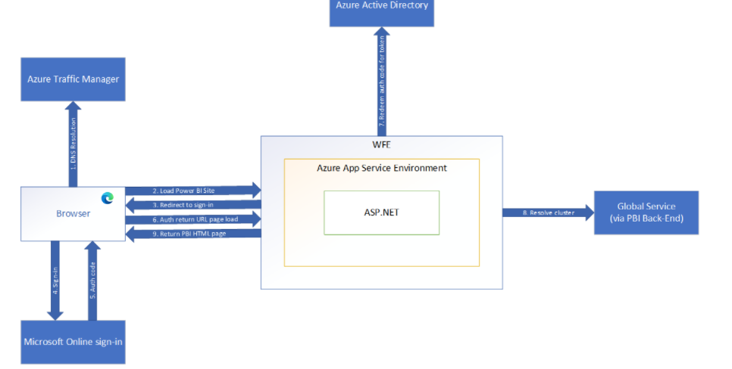

Explain Back End cluster from Power BI Service Architecture?

The Power BI services at the back end take care of visualizations, datasets, storage, reports, data connections, data refreshing, and other interactions with Power BI. At the back-end, a web client has only two direct points of interaction, **Azure API Management**, and **Gateway Role**. These two components are responsible for load balancing, authentication, authorization, routing, etc.

* Power BI stores its data in two main repositories; **Azure block storage** and **Azure SQL database**. Azure block storage stores the datasets uploaded by users and all the metadata and system-related data is stored in the Azure SQL database.
* After Azure API Management authenticates a user request, it is sent to the Gateway Role. The Gateway Role processes the requests and directs them to suitable components like *Presentation Role, Background Job Processing Role, Data Role, and Data Movement Role.*
* For instance, the Presentation Role handles all the visualization related queries like for dashboards and reports.
* For all the data related queries, the request is sent by the Gateway Role to the Data Role or Data Movement Role.
* Power BI Service back end uses Azure Service Bus to connect on-premise [datasources](https://en.wikipedia.org/wiki/Datasource" \t "_blank) with the cloud. Azure Service Bus receives all the requests to fetch data from the on-premise data source. Then it processes the request and executes the query on the on-premise data source to retrieve data from it to the cloud service.
* The Azure Service Fabric manages all the microservices and components associated with running Power BI.
* Azure AD Cache helps in real-time reporting using the data stored in the in-memory of the Power BI system.

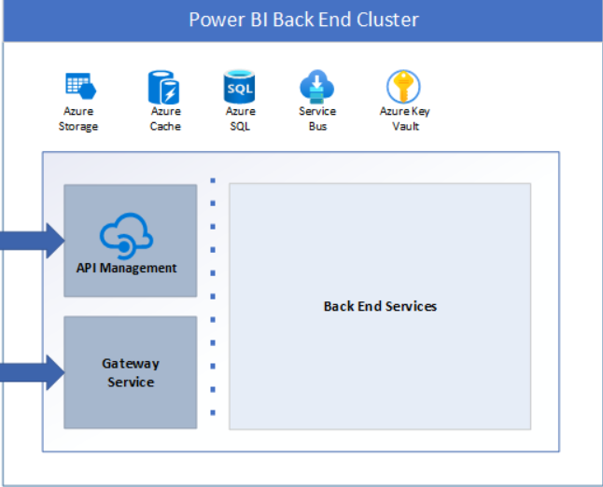

4.What ASP.NET component does in Power BI Service Architecture?

The ASP.NET component within the WFE cluster parses the token to determine which organization the user belongs to, and then consults the Power BI Global Service.

5.Compare Microsoft Excel and PowerBi Desktop on the following features:

Data import

Data transformation

Modeling

Reporting

Server Deployment

Convert Models

Cost

Data import:

Data import in power bi is much simpler to excel moreover power bi doesn’t have limit of 1 million record.

Data transformation:

**Power BI has faster processing than Excel**. Power BI dashboards are more visually appealing, interactive and customizable than those in Excel. Power BI is a more powerful tool than Excel in terms of comparison between tables, reports or data files.

Modeling

For Modelling excel uses power pivot and in Power bi Modelling view is directly available.

Reporting

In excel for reporting we use insert from the menuwhere we can select the all the various chart for the reporting purpose

In powerbi we have reporting view where we can select various visualization to create and then publish it

Server Deployment

In power bi deployment happen with three stage ,development ,testing ,production.

For excel deployment Sideloading, Network Share,AppSource,Microsoft365 centre

Convert Models

Price

Powerbi is available for both paid and free version excel is paid version

List 20 data sources supported by Power Bi desktop.

1. SQL Server database
2. Access database
3. SQL Server Analysis Services database
4. Oracle database
5. IBM Db2 database
6. IBM Informix database (Beta)
7. IBM Netezza
8. MySQL database
9. PostgreSQL database
10. Sybase database
11. Teradata database
12. SAP HANA database
13. SAP Business Warehouse Application Server
14. SAP Business Warehouse Message Server
15. Amazon Redshift
16. Impala
17. Google BigQuery
18. Vertica
19. Snowflake
20. Essbase